# **User Creation & Login:**

## Logging in:

After navigating to the web page, to log into your account, click on the ‘Login’ button on the web page’s navigation bar. This will bring up an overlay box that will have two text boxes, one for your ‘Login’ and the other for your password. Enter your details into the two textboxes and click submit.

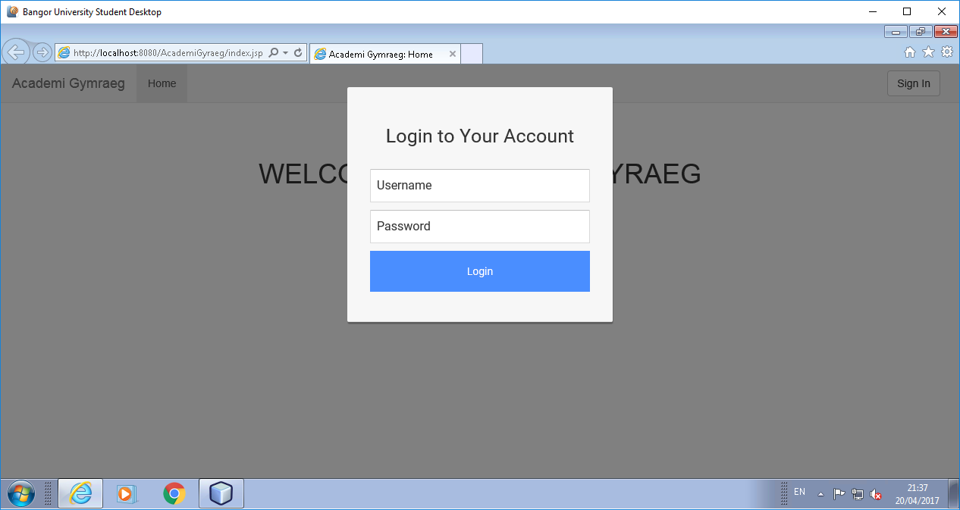

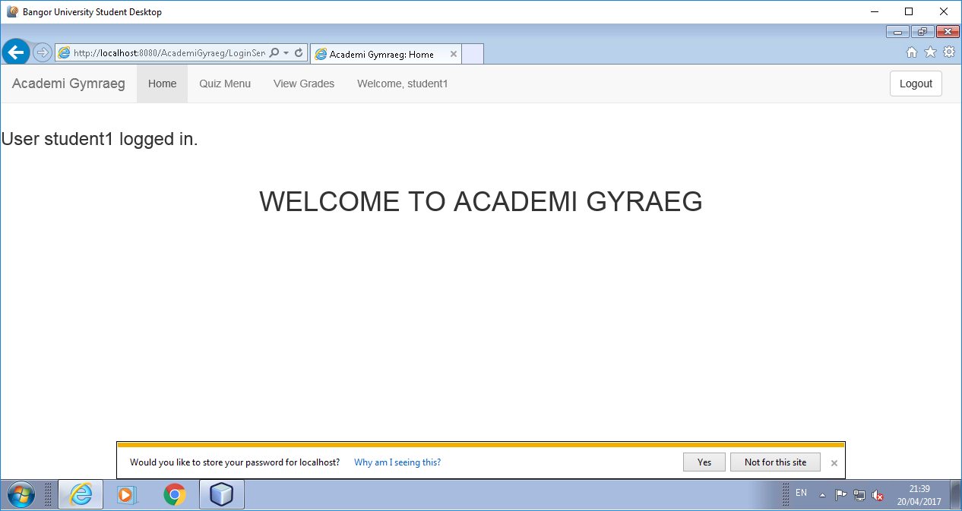

If the information you have provided was correct and the login was a success, the overlay will disappear and you will be redirected to the ‘Homepage’ where you can access the other web pages in relation to your ‘User Type’ security clearance. However if your details were incorrect and the login was unsuccessful and error will appear.

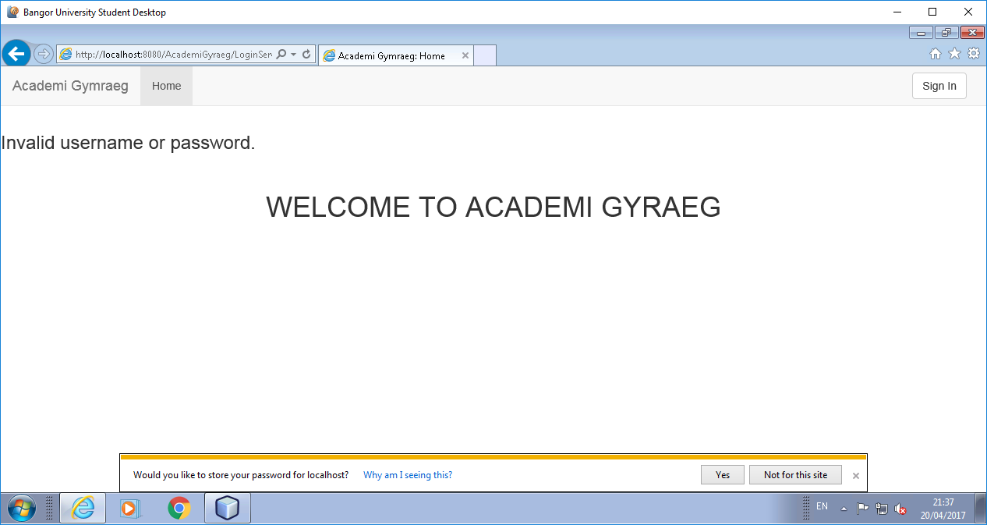

## User Types:

There are three different user types for security of the system who can access different pages.There is a ‘System Administrator’ user type who has access to registering a new user to the system. There is an ‘Instructor’ user type who has access to a dictionary management page and can add/delete/edit entries in the dictionary stored on the database. They can also view ‘Student’ grade history. There is a ‘Student’ user who can take quizzes on the system and view all previous grades.

## New User Creation:

After logging into the system as a ‘System Administrator’ user, to create a new user, click on the ‘Register’ button located on the web page’s navigation bar. This will bring up an overlay that allows you to register a new user by entering the ‘Username’ and ‘Password’ and clicking submit. After filling in the text boxes and selecting what type of user you are registering you can submit your changes and the new user will be created, with a confirmation message.

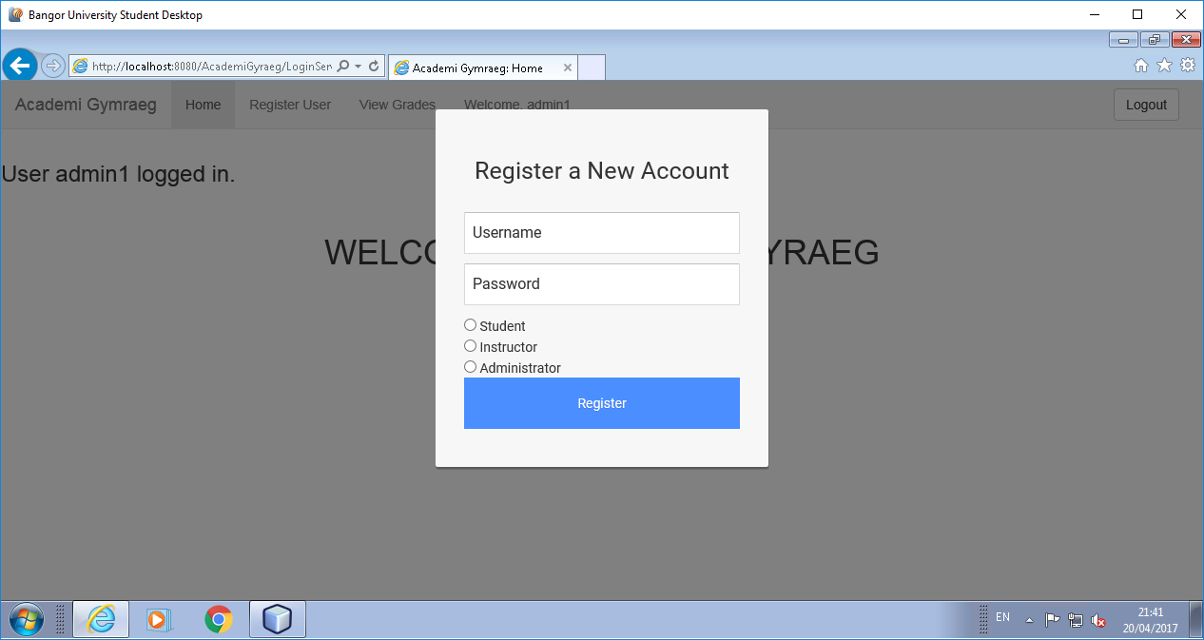

### Validation

Usernames must be a string with a maximum of 56 characters.

Passwords must be a string with a maximum of 256 characters.

Accounts are assignment a type. Students are type 0, instructors are type 1, and administrators are type 2.

## Viewing Profile History:

If you’re logged in as a ‘Instructor’ user, you can view the grade history of all of the ‘Student’ users. Navigate to the ‘View Grades’ webpage from the navigation bar. This will take you to a page with a table of every result in the database. Enter a student username into the search to refine the table. This will bring all the quiz history details of the student to the table.

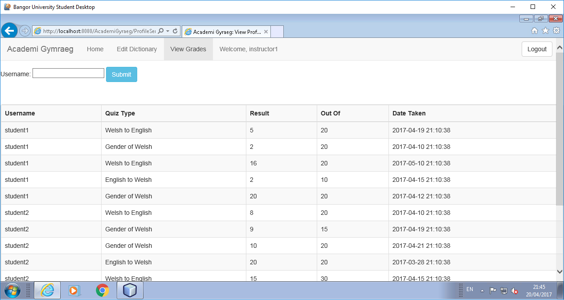  
  
If you’re logged in as a ‘Student’ user, you can view your own grade history by navigating to the ‘View Grades’ webpage from the navigation bar. This will take you to a page that displays a table that has all of your previous grade history for you to view.

# **Dictionary Management:**

## Adding New Words:

After logging in as an ‘Instructor’ you can view the current dictionary, in the form of a table. To add a new view, select the ‘New Word’ radio, and press ‘Submit’ at the bottom. This will bring you to a small menu, where you can enter the details of the new word. Press submit to add it, and return to the dictionary.

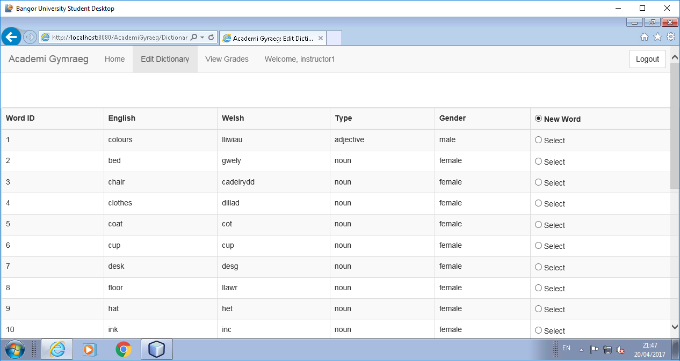

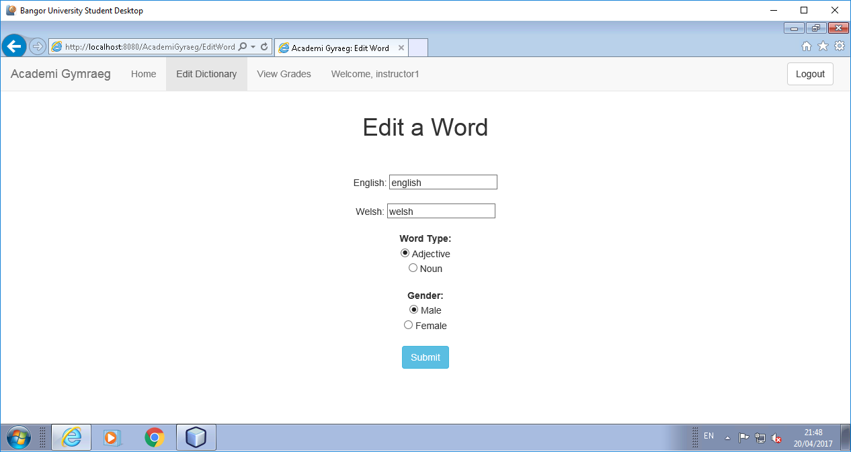

## Editing Existing Words:

You can edit words in the dictionary by selecting the radio button in the row of the word you would like to change. Pressing submit at the bottom will then bring you to a small menu, which will already hold the existing values. Change the properties you wish, then hit submit to save the changes.

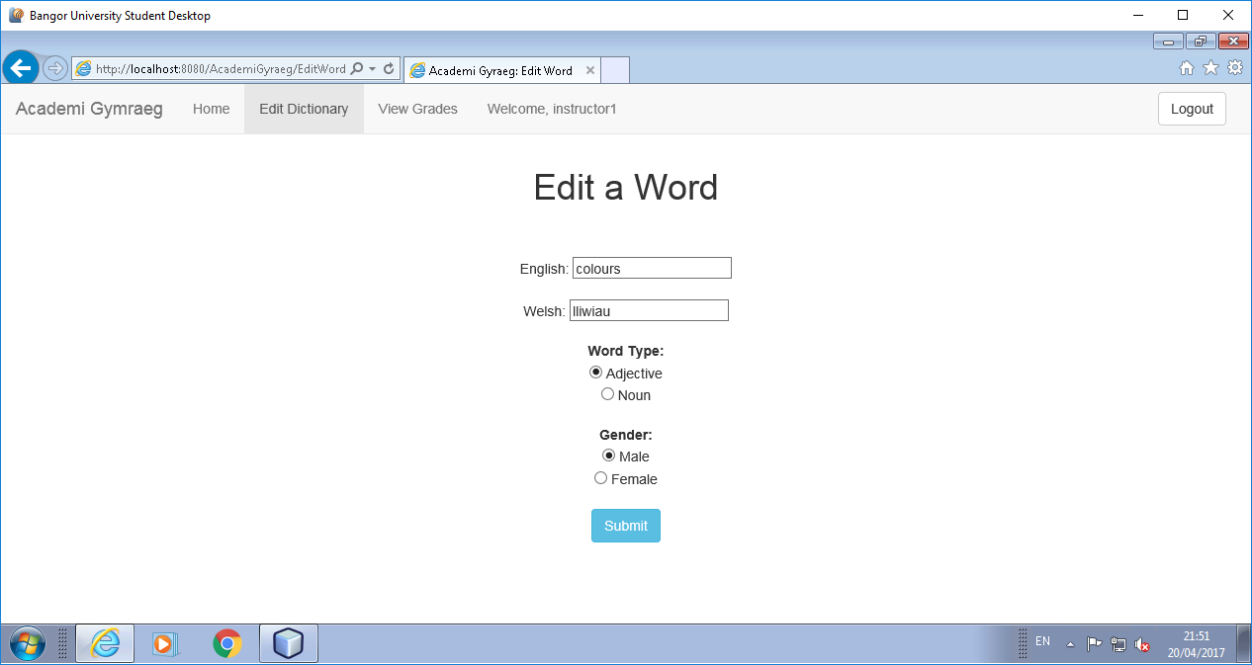

## Deleting Existing Words:

You can delete words in the dictionary by selecting the radio button in the row of the word you wish to delete. Press the delete button at the bottom, and the word is removed from the dictionary.

# **Quiz Guide:**

## Types of Quiz:

There are three different forms of quiz for a Student user to attempt;

1. Recalling Welsh for an English word quiz, this gives you an English word and asks for the Welsh translation of this word.
2. Recalling English for a Welsh word Quiz, this gives you a Welsh word and asks for the English translation of this word.
3. Determining the gender of a Welsh word, this gives you a welsh word and asks for the gender of the word (Male, Female).

## Taking a Quiz:

To take a quiz, you must first be logged into a ‘Student’ user account, then navigate from the homepage to the ‘Quiz Menu’ page from the navigation bar. This allows you to make a choice of which quiz type you’d like to attempt. Once a radio button is selected you will be redirected to a ‘Quiz’ page where a random selection of words from the dictionary are displayed.

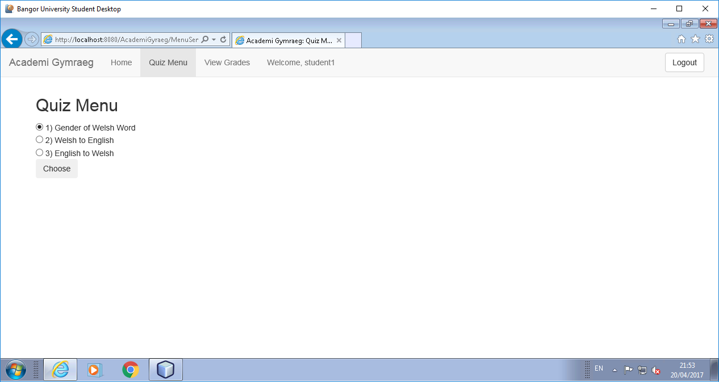

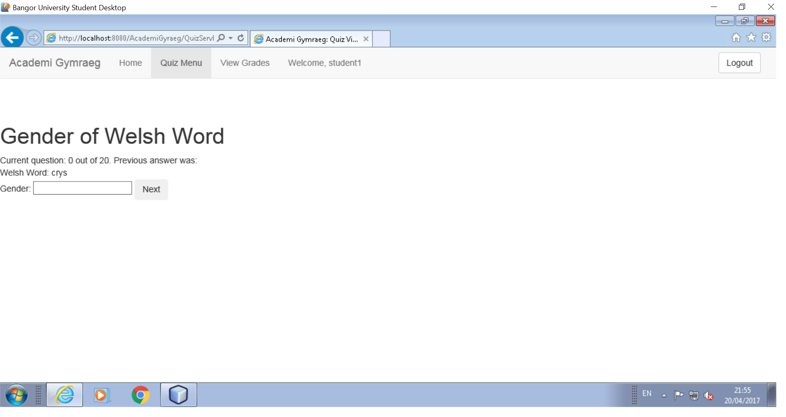

The question, current word number, and total questions will be display. Enter your answer in the text and hit next. Repeat this until the quiz is complete.

## Viewing Quiz Results:

After your answers have been submitted you will be redirected to a ‘Quiz Result’ page where your score is displayed telling you how many questions you got correct. This is then stored on the database ready for you to review in your grade history.

